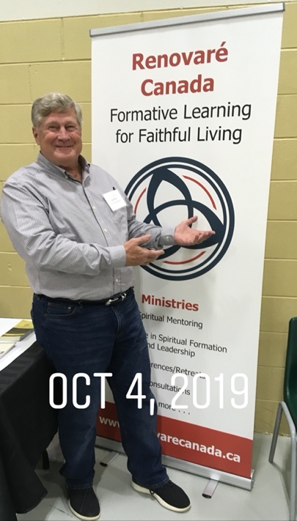

**David E. Root**

**Personal:**

My wife, Jeanine, and I have three children—Laura, Heather, and Samuel; two sons-in-law—Michael and Ryan; one daughter-in-law, Amara; and seven grandchildren—Chloe, Forest, Renee, Dahlia, Hunter, Meredith, and Saoirsa. I enjoy reading, fellowshipping with friends, traveling, bicycling, and hiking

**Education:**

I graduated from East Anchorage High School and attended Anderson College before being drafted into the Army in January 1971. After serving in the Army I graduated from the University of Houston with a Bachelor of Science in 1975 and a Master of Arts in Social Science Education in 1978. I then taught school for a year and returned to Anderson, Indiana and graduated from Anderson School of Theology in 1980 with a Master of Divinity. In 2014, I graduated from Houston Graduate School of Theology with a Doctor of Ministry.

While serving in the Army my military education includes graduating from the Command and General Staff College in 1998 at Leavenworth, Kansas and then the Joint Forces Staff College in 2005 at Norfolk, Virginia.

**Professional:**

The Church of God ordained me for Christian ministry in 1983 while I served as an associate pastor in California. I was commissioned as a Chaplain in the U. S. Army in 1987. I served on active duty during the Vietnam War, 1971-73; Desert Storm, 1987-1995; and Afghanistan/Iraq (OEF & OIF), 2001-2009. I retired from the Army in 2009 after a total of 32 years of service—17 years as a reservist and 15 years on active duty.

I have served as a TIPS minister since 2017—serving 7 congregations in three denominations. I served the Texas Ministries of the Church of God as Secretary of the Board of Ministry from 2019-24 and Dean of Texas Ministry Academy from 2015-17. I served Leadership Focus as Ministry Candidate Debrief/Summary Report Coordinator and taught Course 5 from 2017-22.